Practicum Final Exam – Odd Semester Year 2021/2022
Subject |  |  | COMP6153001 - Operating System |  |  | 
Class | : | B001 / B101 / BA02 / BS01 / BT01 |  | Start Date | : 18 Januari 2022
Lecturer | : | D2632 - Dr. Zulfany Erlisa Rasjid, B.Sc., MMSI.  D3089 - Rubil, S.T., M.T.  D3366 - Bayu Kanigoro, S.Kom., M.T. |  | Start Time | : 15.20
Lecturer | : |  |  | End Date | : 18 Januari 2022
Lecturer | : |  |  | End Time | : 17.20

PERATURAN UJIAN:
Exam Regulations:
- Mahasiswa tidak diperbolehkan berdiskusi dan/atau bekerja sama dengan peserta ujian lainnya
Student is not allowed to discuss and/or work together with other exam participants
- Mahasiswa tidak diperbolehkan untuk membuka dan menyalin dari BUKU atau CATATAN, VIDEO dari pengajar (recording kelas, VBL, Youtube, dsb) dan REFERENSI lainnya
Student isn't allowed to open and copy from any resources such as notes, videos (class recording, VBL, Youtube, etc) and other references
- Mahasiswa tidak diperbolehkan membuka dan menyalin jawaban dari internet (google, stackoverflow, dsb)
Student isn't allowed to open and copy answer from the internet (google, stackoverflow, etc)
- Asisten BERHAK memberi nilai 0 (NOL) bagi peserta ujian yang melakukan segala bentuk kecurangan
Assistant is able to give 0 (ZERO) score for exam participant who does any cheating actions
- Kumpulkan jawaban tepat pada waktunya, apabila terlambat mengumpulkan maka jawaban tidak akan dikoreksi dan nilai mahasiswa adalah 0
Submit the answer on time, if not, then the answer will not be checked, and the students will receive 0 (ZERO)
- Bila Anda tidak membaca peraturan ini, maka Anda dianggap telah membaca dan menyetujuinya
If you have missed to read these regulations, so you are considered to have read and agreed on it



SOFTWARE YANG DIGUNAKAN:
Software will be used:
- Eclipse 2020.6
- Java 8
- NachOS 5.0j
- VM Ubuntu Client 20.04
- VMware Workstation 16

FILE YANG DIKUMPULKAN:
File must be collected:
- JAVA
- CLASS

PERHATIAN!
Attention!
- Bagi yang mengerjakan tidak sesuai dengan soal, maka akan diberikan nilai NOL (0)
For those who do not work in accordance with the exam case will be marked as ZERO (0)
- Bagi yang mengerjakan tidak sesuai dengan software dan versi yang telah ditetapkan, maka akan tetap dikoreksi dengan software dan versi yang telah ditetapkan
For those who do not work in accordance with the software and specific version will be corrected by the predefined software and version
- Kompres semua jawaban yang akan diunggah. Pastikan format pengumpulan nama file dan ekstensi sesuai dengan format berikut: [NIM]-[NAMA].zip
Compress all file that will be uploaded. Make sure the format for collecting file name and extension according to the following format: [NIM]-[NAME].zip

Important Notes:
- Use your own Console and Scheduler.
- You must use Semaphore to control operation.
- You must use Timer to print tick of time.
- Use KThread to view existing messages.

Soal
Case

FAmouz amoz
FAmouz amoz is a popular cookie shop in town, the cookie shop wanted to make an application with intention of managing user favorite cookie. The features provided in this application are inserted, save, and delete cookie. As a programmer, you are asked to create the application using nachOS in Java programming language.
In the start of the application, the program will look for a file named “CookieList.txt” which will be converted into an acceptable cookies data and load it into the system with the help of file system if the file is available.
After the said process has been completed, the application will then show 4 menus which represent features in the application which are:
- Add Cookie
- Remove Cookie
- View All Cookie
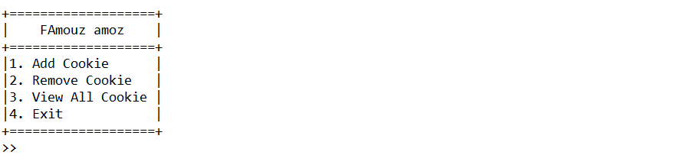
- Exit
Figure 1. Main menu

- Add Cookie
The first menu option let the user inserts a new cookie into the system. This option requires the user to input information regarding the cookie that follows the following detail which are:
- Ask the user to input cookie name. The cookie name must end with ‘Cookie’.
Figure 2. Name input

- Ask the user to input cookie size. The cookie size must be either “Small”, “Medium”, or “Large” (Case Sensitive).
Figure 3. Size input
- Ask the user to input cookie price. The cookie price must be between 20000 – 100000.
Figure 4. Price input

- After all the required input has been filled, save the input to file named “CookieList.txt” with the following format and show success message to the user.
[Cookie Name]#[Cookie Size]#[Cookie Price]
Figure 5. Success message

- Remove Cookie
The second option in the menu allows the user to remove a cookie from the list. The deleting process follows the following steps which are:
- Check if cookie list has any data. If the cookie list didn’t have any data, the application will show an error message to the user.
Figure 6. Remove validation
- Otherwise, the application will print all cookie on cookies list and ask the user which cookie index that want to be deleted. The deleted index starts from 1 to cookie list data size.
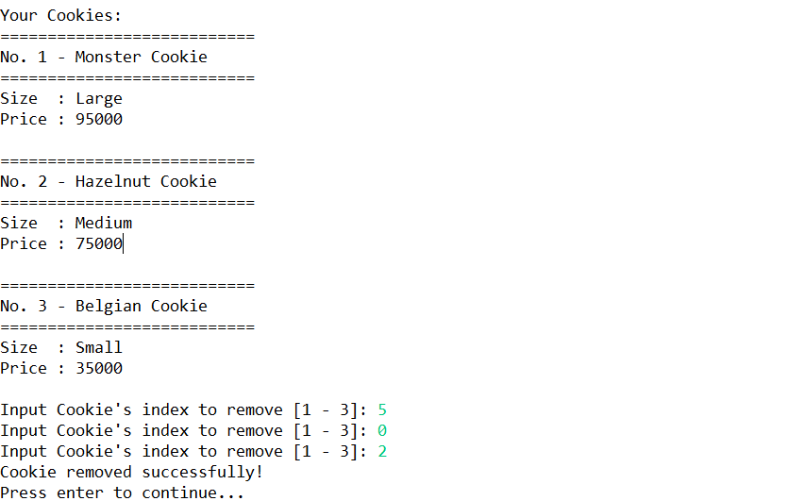
Figure 7. Remove Cookie
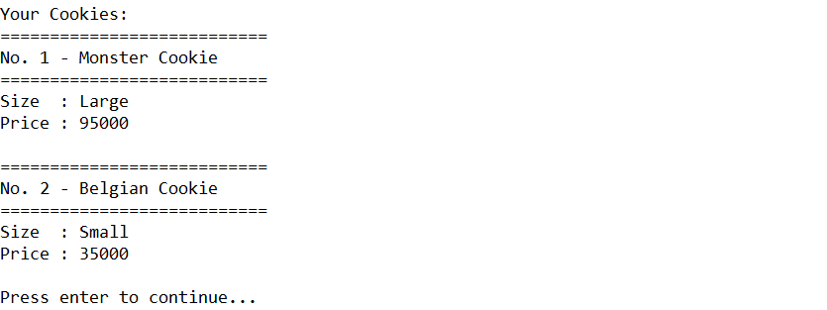
- After cookie deletion has been completed successfully, update the data in file “Cookielist.txt” and direct the user back to the main menu.
Figure 8. Cookie list after deletion

- View All Cookie
The third option of the menu (View All Cookie) allows the user to view all data read by the file system. The process follows the following steps which are:
- Check if cookie list has any data. If the cookie list didn’t have any data, the application will show an error message to the user.
Figure 9. View validation
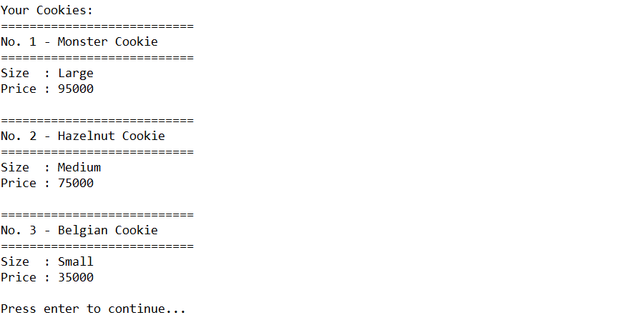
- The application will show all files received using KThread and Scheduler (FIFO concept). The cookie will be shown with delay 1000 milliseconds (using Thread sleep).
Figure 10. View all data
- Exit
If the user chooses the fourth Menu (Exit), the application will print tick of time using a timer.
Figure 11. Exit

